DAILY CANTEEN MENU & FEEDBACK PORTAL
@CREATIVITY THINK (9483175986/7019689991)

ABSTRACT:
Daily Canteen Menu & Feedback Portal is a web-based system designed to manage and monitor daily menus and collect feedback for college canteens, office cafeterias, and hostels. The platform allows users to view daily menus, rate dishes, submit suggestions, and track weekly rating trends. Administrators can post and edit menus, monitor dish-wise feedback, identify popular or underperforming items, and generate monthly feedback reports. Built with Django and Django REST Framework for backend services, and React with axios and recharts for frontend interactivity, the portal ensures streamlined menu management, real-time feedback collection, and insightful analytics..

INTRODUCTION OF THE PROJECT:
Canteens and cafeterias often struggle to gather structured feedback from patrons and track the popularity of menu items. Manual collection of ratings and suggestions is inefficient, prone to errors, and does not provide actionable insights. The Daily Canteen Menu & Feedback Portal addresses these challenges by offering a centralized platform for menu publishing, dish-wise ratings, feedback submission, and data-driven analytics. Users can quickly provide input, while administrators can make informed decisions to optimize menu offerings and improve customer satisfaction..

PROJECT OBJECTIVES:

• Provide a digital platform for publishing daily and weekly menus
• Enable users to rate dishes, submit feedback, and mark favorites
• Track dish-wise feedback and overall menu ratings
• Offer weekly trend visualization for popular and underperforming dishes
• Allow administrators to add, edit, or remove menu items and prices
• Provide charts and analytics to assess user satisfaction
• Export monthly feedback reports for documentation and insights
• Enhance communication between canteen staff and patrons
• Improve menu planning and customer engagement

PROBLEM OF THE STATEMENT:
Canteens and cafeterias often receive unstructured feedback through verbal comments or paper forms, making it difficult to identify popular items or address issues promptly. Without real-time analytics, menu planning is guesswork and patron satisfaction may decline. This project solves these problems by offering an organized, digital system for menu management, quick feedback collection, and analytics to help administrators optimize offerings and enhance user experience..

MOTIVATION OF THE PROJECT:
• To simplify daily menu management for canteen staff
• To capture structured, real-time feedback from patrons
• To reduce manual tracking errors and paper-based processes
• To identify popular and low-performing dishes for better planning
• To enhance user engagement through ratings and favorite tracking
• To generate actionable insights for menu improvement
• To provide an intuitive and user-friendly interface for both users and admins
• To improve overall satisfaction and efficiency in canteen operations

BLOCK DAIGRAM OF PROJECT:

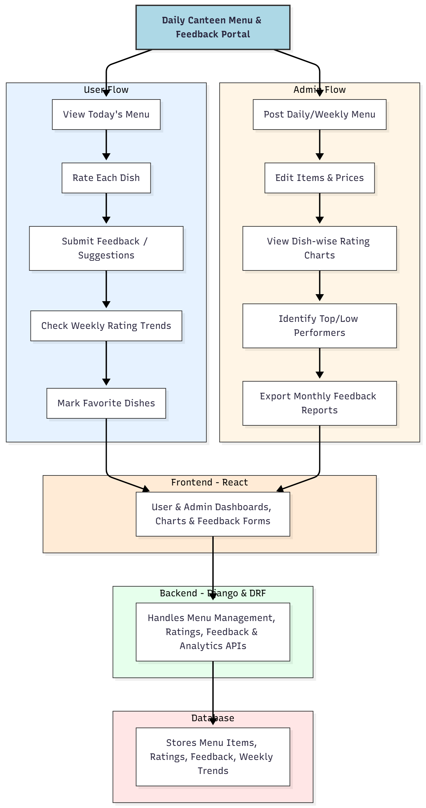

WORKING OF THE PROJECT:
Users access the portal to view the current day’s menu and rate each dish. They can submit quick feedback or suggestions and mark favorite items for easy tracking. Weekly trend charts are displayed to highlight popular dishes.
Administrators post daily or weekly menus, modify item details and prices, and monitor dish-wise ratings. Analytics dashboards help identify top-performing and low-performing dishes, while monthly reports can be exported for review. The backend manages all API requests, stores feedback data, calculates trends, and ensures real-time updates on the frontend. This workflow ensures efficient communication between patrons and canteen management, improves menu planning, and encourages user participation..

SOFTWARE REQUIREMENT:
- Backend:
  - Python 3.x
  - Django
  - Django REST Framework
  - SQLite/PostgreSQL
- Frontend:
  - Node.js and npm
  - React.js
  - Axios
- Development Tools:
  - Visual Studio Code
  - Postman (for testing APIs)
  - Git/GitHub (for version control)
- Server/Deployment (Optional):
  - Gunicorn, Nginx, or Heroku/AWS for hosting

ADVANTAGES OF THE PROJECT:

• Streamlines menu management and feedback collection
• Provides real-time dish ratings and trends
• Reduces manual paperwork and errors
• Identifies popular and underperforming dishes
• Generates actionable insights for canteen operations
• Supports better planning of menus and pricing
• Increases patron engagement and satisfaction
• Provides structured reporting and analytics

APPLICATIONS OF THE PROJECT:
• College and university canteens
• Office cafeterias
• Hostel dining services
• Corporate kitchens
• Any institutional food service setting

REFERENCES:

- Django REST Framework Documentation — Django Software Foundation. Django Documentation. Available: https://docs.djangoproject.com/
- Django REST Framework. DRF Documentation. Available: https://www.django-rest-framework.org/
- React. React Official Documentation. Available: https://reactjs.org/docs/getting-started.html
- Redux. Redux Documentation. Available: https://redux.js.org/introduction/getting-started
- PostgreSQL Global Development Group. PostgreSQL Documentation. Available: https://www.postgresql.org/docs/
- MySQL. MySQL Reference Manual. Available: https://dev.mysql.com/doc/
- Git. Git Documentation. Available: https://git-scm.com/doc
- Node.js. Node.js Documentation. Available: https://nodejs.org/en/docs/
- Axios. Axios Documentation. Available: https://axios-http.com/docs/intro
- Socket.io Documentation – https://socket.io/docs/

